Daily Report
Date : 04.02.26

Task Report: A Board has multiple Column (e.g., "To Do", "In Progress", "Done") has multiple Columns Task . Implement CRUD endpoints for tasks within a specific column/board .Model the core Kanban logic.
Today Working: Today’s work focused on designing and implementing the core Task board functionality for the Project & Board management application, covering both backend and frontend development.
Backend Development:
• Designed and implemented the data models for Board, Column, and Task using MongoDB and Mongoose.
• Established relationships between entities:
Board → Columns → Tasks.
• Developed REST-full API endpoints to support:
- Create, update, delete, and retrieve columns by board.
- Create, update, delete, and retrieve tasks by column.
Frontend Development:
- Implemented a Task Board Page with:
  - Dynamic rendering of columns (e.g., To Do, In Progress, Done).
  - Task cards displayed within each column.
  - Full CRUD functionality for both columns and tasks.

Screenshots :
Project Page:
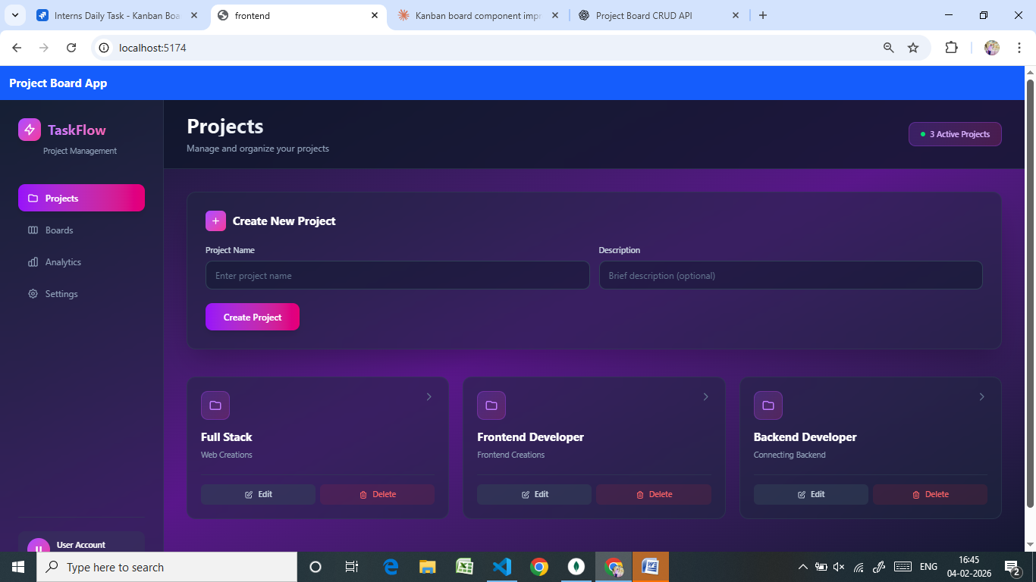
Board Page:
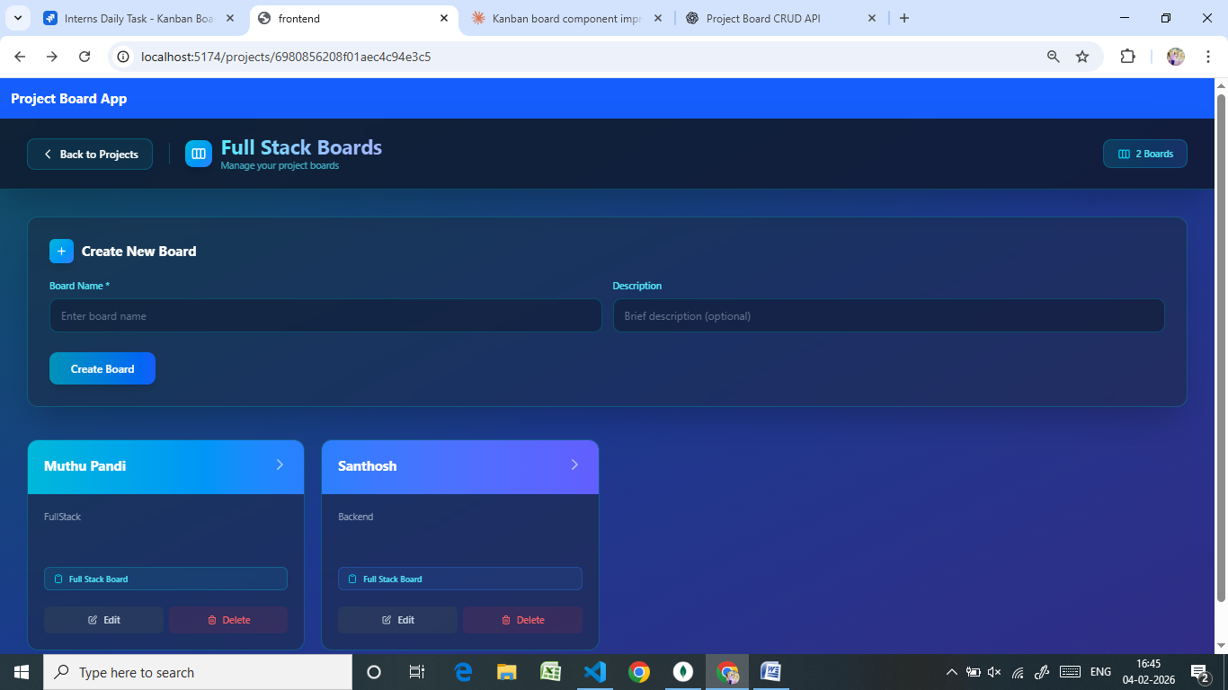

Tasks Board Page:
